Early Payment Default Prediction for Mortgage Loans:
Technical and Non-Technical Capstone Report

Siobhan M Curran
Faculty of Computing and Data Sciences, Boston University
DX799: Data Science Capstone
Dr. Joshua Von Korff
December 12, 2025

Topic Description
This project addresses the problem of Early Payment Defaults (EPDs) in mortgage lending by utilizing a hybrid analytical framework that combines supervised classification and unsupervised clustering. By optimizing Gradient Boosting decision thresholds and identifying high-risk borrower segments, the analysis demonstrates how lending institutions can significantly reduce financial losses. The findings identify that metric-driven evaluation and targeted policy adjustments are essential for mitigating the risks associated with rare-event defaults.
Datasets Used:
- Home Credit Default Risk: https://www.kaggle.com/competitions/home-credit-default-risk/data
- Give Me Some Credit: https://www.kaggle.com/c/GiveMeSomeCredit/overview
- Loan Data: https://www.kaggle.com/datasets/abhishek14398/loan-dataset
Technical Report: Early Payment Default Prediction
1. Executive Summary
1.1 Project Overview and Business Problem
The objective of this project is to develop a predictive machine learning framework capable of identifying Early Payment Defaults (EPDs), which are defined as home loans that become delinquent in the first six months (Fannie Mae, 2021). By identifying high-risk borrowers prior to funding the loans, lenders can preserve liquidity and reduce operational overhead. EPDs cause severe financial burdens for lenders resulting in a more than tenfold increase in servicing costs per loan ($176 to $1,857 per loan annually) and fixed penalty costs of $1,500 to $7,500 per loan from investors, which excludes the additional capital losses associated with repurchasing distressed assets (Cotality, 2025; Fannie Mae, 2021; Goodman et al., 2023).
1.2 Methodology and Data Strategy
After evaluating a range of algorithms--from linear baselines to ensemble methods--Gradiant Boosting prevailed due to its ability to capture non-linear risk factors in highly imbalanced data (7 - 8% overall default rate). To ensure robustness and generalizability, I aggregated data from three distinct data sets with different lending environments: Home Credit, Give Me Some Credit, and Lending Club. This approach combined supervised learning for direct risk prediction with unsupervised clustering for borrower segmentation.
1.3 Key Findings
Gradient Boosting achieved a stable Precision-Recall AUC (PR AUC) of 0.226. The standard 0.50 cutoff for the sensitivity of the decision threshold was ineffective for rare-event default detection resulting from an F1 score of 0.017. However, optimizing the threshold to 0.1388 dramatically improved the F1 score to 0.294, demonstrating a measurable gain in sensitivity to the rare-event default class. Additionally, unsupervised K-Means clustering (k=2) revealed distinct borrower groups, specifically identifying Cluster 1, a segment characterized by significantly higher loan amounts and interest rates (mean of 16.3%), effectively classifying it as a distinct high-risk profile independent of historical labels.
1.4 Recommendations and Business Impact
I recommend enhancing underwriting workflows with a second look filter that could intercept approximately 35% - 40% of early loan defaults that are undetected by current standard lending models. Projected across the industry, this capability could achieve an estimated savings of $56 - $64+ million annually in avoided fees and servicing costs alone, in addition to capital and operation losses, plus repurchase demands from secondary market investors.
2.Introduction and Problem Definitions
2.1 Background and Domain Context
Unlike long-term defaults, which are often driven by unforeseen life events such as unemployment, medical emergencies, or divorce, EPDs typically indicate that the borrower was financially unstable at the time of loan approval.
This project addresses a blind spot in traditional home loan underwriting. Standard risk metrics, such as Debt-to-Income (DTI) ratios and FICO scores, assume linear relationships between financial health and repayment probability. However, these metrics often fail to capture complex, non-linear risk factors that cause underwriters to approve loans that are destined to fail. The ability to predict these rare but costly events using machine learning has become a competitive advantage.
2.2 Client Goals, Needs, and Objectives
The objective is twofold: minimize the frequency of EPDs (false negatives) while maintaining a competitive approval rate (avoiding excessive false positives). By using machine learning to identify high-risk applications before funding, the institution can trigger an enhanced manual underwriting review to prevent the origination of bad debt. The costs associated with defaulted loans are higher than the costs of flagging good loans for secondary review.
As a former FHA underwriter, I have experienced the operational pressures that contribute to EPDs. Underwriters can be subject to punitive and reactive audits that occur when a loan has defaulted. Current underwriting workflows rely heavily on manual checklists and static thresholds (e.g., "DTI must be < 43%"). Rigid rules can force underwriters to approve loans that "technically" qualify but feel intuitively risky due to layered risk factors. The blind spot in the current system is the inability to quantify this layered risk in real-time. When a reactive audit occurs, the capital is already lost. This project aims to reduce reactive audits in favor of pre-approval safety nets.
2.3 Research Questions
I evaluated three core research questions regarding model performance, feature importance, and borrower segmentation. Firstly, I analyzed if machine learning algorithms, specifically Gradient Boosting, can outperform traditional linear models in identifying EPDs when controlling for class imbalance. Secondly, I evaluated if the inclusion of soft behavioral features (such as recent credit inquiries and revolving utilization) provided stronger leading indicators for early default compared to static metrics. Finally, I explored whether unsupervised clustering identified if distinct borrower profiles that correlate with high default rates, independent of supervised labels.
2.4 Success Criteria
Success in this project is defined by the model's ability to operationalize risk detection in a highly imbalanced environment. Given that defaults represent only roughly 7 - 8% of the population, standard accuracy is a misleading metric. Instead, the project prioritizes Recall (sensitivity) for the minority class, with a measurable target of achieving a Recall greater than 0.35. This threshold ensures the model captures at least 35 - 40% of actual EPDs. Simultaneously, the model must maintain a Precision greater than 0.20 to minimize false alarms. Finally, the optimized model must demonstrate a significant improvement in the F1-Score over the baseline Logistic Regression model (baseline F1 < 0.10), proving that the complexity of machine learning adds value.
2.5 Scope, Assumptions, and Constraints
To ensure a comprehensive evaluation of borrower risk, I extended the analysis beyond traditional mortgage portfolios. While the Home Credit Default Risk and Give Me Some Credit datasets serve as the primary proxies for residential mortgage default (reflecting a baseline default rate of 7–8%), I broadened the scope to include the Lending Club dataset. This dataset encompasses unsecured personal loans, credit card refinancing, and major purchase financing. Including this diverse portfolio allows for the evaluation of soft borrower features (such as employment title and loan grades) that are often absent in anonymized mortgage data. Since the Lending Club dataset is not specific to mortgages, I am excluding its default rate.
Table 1: Summary of Data Structures
Dataset | Total Samples (Rows) | Total Features (Cols) | Target Variable | Minority Class (Default) Rate
Home Credit Default Risk | 307,511 | 122 | TARGET (1 = Default) | 8.10%
Give Me Some Credit | 150,000 | 11 | SeriousDlqin2yrs (1 = Yes) | 6.70%
Lending Club | 39,717 | 111 | loan_default (1 = Charged Off) | ~14.6% (post-filtering)

However, a significant scope limitation was applied to the Lending Club source. The original dataset, containing over two million rows, proved computationally prohibitive and suffered from high data sparsity across 151 columns. Consequently, the analysis was restricted to a curated subset (loan.csv) of 38,577 records. This subset was selected for its data completeness and features sufficient to support the granular segmentation required for the K-Means clustering analysis.
A primary assumption of this study involves the definition of the target variable. Direct counts of new loans that experience true EPD are proprietary metrics and are not publicly reported (Fannie Mae, 2021). I therefore assume that serious delinquency within 2 years serves as a valid proxy for EPD risk. Specifically, the model relies on the premise that the risk factors driving the 2.1% of mortgages in early-stage delinquency (comprising 1.6% at 30–59 days past due and 0.5% at 60–89 days past due) are statistically like those driving immediate payment default. This proxy introduces noise into the target variable. A borrower defaulting in month 22 may do so due to unforeseen life events rather than the poor underwriting quality associated with true EPDs. The analysis assumes that supervised learning models can sufficiently distinguish these signal patterns despite this label noise.
Constraints The analytical approach was strictly bound by three technical constraints:
- Data Leakage Prevention: The model design was constrained by the need to strictly exclude post-funding variables. Features such as 'Recoveries' and 'Collection Fees' were identified and removed during preprocessing to ensure the model predicts risk solely based on information available at the time of origination.
- Class Imbalance: The severe imbalance between compliant borrowers and defaulters (approximately 93:7 ratio across portfolios) imposed a mathematical ceiling on standard accuracy metrics. This constraint necessitated the use of specialized threshold tuning and evaluation metrics focused on Recall rather than overall Accuracy.
- Proxy Limitations: As noted in the assumptions, the lack of confirmed repurchase Demand labels limits the model's ability to isolate underwriting errors from general credit risk perfectly.
Figure 1: Bar Chart of Loan Default Distribution (Illustrates Target Imbalance)
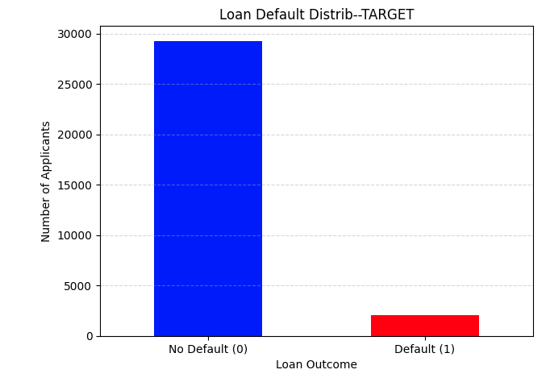
3. Data Overview
3.1 Data Sources and Collection Strategy
I obtained data from three distinct lending environments: Give Me Some Credit, Home Credit Default Risk, and Lending Club Loan Data. I performed a targeted search of public data repositories to identify high-quality datasets containing historical loan performance metrics. The Kaggle platform was selected as the primary source due to its aggregation of anonymized financial datasets from recognized providers. I selected three specific datasets based on their feature granularity (e.g., inclusion of external risk scores and interest rates) and sufficient volume to support robust machine learning:
- Home Credit Default Risk: challenges the model to predict default without relying on traditional credit scores, utilizing alternative transactional data.
- Give Me Some Credit: heavily weighted toward distressed borrowers, providing a critical signal for delinquency prediction.
- Lending Club Loan Data: diverse portfolio allows for the evaluation of soft borrower features (such as employment title and loan grades) that are often absent in anonymized mortgage data. Enables detailed borrower profiling through unsupervised clustering.
3.2 Data Description and Characteristics
The selected datasets primarily consist of numeric features relevant to borrower profiles including age, income, and credit scores. A critical characteristic across all portfolios was the severe class imbalance. In the Home Credit dataset, only 8.1% of applicants defaulted, while the Give Me Some Credit dataset showed a similar imbalance with approximately 93% non-default versus 7% default. The Lending Club subset contained roughly 85% non-defaults; however, this is not indicative of true mortgage defaults as it includes other types of loans. This consistent imbalance necessitated the use of specialized evaluation metrics.
3.3 Data Dictionary
The analysis focused on a curated subset of features most relevant to EPDs. Table 2 defines the primary variables used across the modeling stages.
Table 2: Data Dictionary of Key Features
Variable Name | Description | Role in Analysis
TARGET / SeriousDlqin2yrs | Binary flag (1 = Default, 0 = Repaid). | Dependent variable for supervised models.
EXT_SOURCE_1 / 2 / 3 | Normalized scores from external credit bureaus. | Top predictors in Gradient Boosting; credit score proxies.
DAYS_BIRTH | Client's age in days (negative). | Converted to positive age (AGE) to assess lifecycle risk.
RevolvingUtilization | Ratio of total balance to credit limit. | Financial stress indicator used in the KNN model.
DebtRatio | Monthly debt/living payments divided by gross income. | Primary measure of monthly financial burden/stress.
int_rate | Interest rate on the loan. | A proxy for the lender's internal risk assessment; used in clustering.
dti | Debt-to-Income ratio (monthly debts / total obligations). | Critical indicator of borrower leverage and repayment capacity.
inq_last_6mths | Number of credit inquiries in the last 6 months. | Credit-seeking behavior indicator.
AMT_INCOME_TOTAL | Annual income of the applicant. | Used to assess repayment capacity.
AMT_CREDIT | Final loan amount. | Used to measure exposure and leverage.
INCOME_CREDIT_RATIO | Total income ÷ credit amount. | Borrower leverage indicator; higher implies stronger capacity.
3.4 Data Quality
Data quality issues were addressed prior to modeling. My assessment revealed three primary challenges, including data availability limitations, that dictated the analytical strategy:
- Missing Values: In the Give Me Some Credit dataset, the MonthlyIncome feature was missing nearly 20% of its values. I imputed these using the median to avoid the skewing effects of high-income outliers.
- Anomalies and Outliers: In the Home Credit dataset, a comprehensive data quality scan revealed anomalies in the DAYS_EMPLOYED feature, which contained a recurring placeholder value of 365,243 (representing ~1,000 years). These records were identified as data entry errors and filtered out.
- Multicollinearity: Assessment using the Variance Inflation Factor (VIF) revealed high redundancy among financial features. Notably, AMT_GOODS_PRICE showed a VIF > 39 due to its high correlation with AMT_CREDIT, indicating a need for feature removal to prevent model instability.
3.5 Ethical Considerations
The datasets utilized are publicly available on Kaggle and are anonymized, however, financial data can contain societal (gender, ethnicity, etc.) or sampling biases. Since the derived models are designed to determine creditworthiness and ultimately influence lending decisions, they must be audited for fairness metrics during implementation to ensure they do not perpetuate discriminatory lending patterns by relying on features that serve as proxies for protected characteristics. I utilized explainable algorithms (Gradient Boosting, Decision Trees) over "black box" models. In a regulated industry, it is critical that an employee can document and explain the specific factors leading to a flag for review. Finally, I executed a data leakage scan to ensure no post-loan outcomes (like recoveries) were included, ensuring the model's fairness by evaluating borrowers only on information available at the time of application.
4. Data Cleaning, Preprocessing, and Exploratory Data Analysis
I performed data cleaning to address issues such as missing values and outliers, as these can severely distort the distance-based algorithms.
4.1 Data Cleaning and Leakage Prevention
I evaluated missing data across all three portfolios to determine the appropriate imputation strategy. For the Home Credit Default Risk dataset, I identified null values in property-related features, such as COMMONAREA_MEDI which was missing over 213,000 values (~69%). To avoid imputing signals from noise, I dropped columns with greater than 60% missing values. I also removed zero-variance predictors prior to Gradient Boosting to improve computational efficiency and model interpretability. For the Give Me Some Credit dataset, the MonthlyIncome feature was missing 29,731 values (19.82%). I chose median imputation rather than mean imputation because the income distribution was highly right-skewed; using the mean would have biased the baseline upward due to high-income outliers, whereas the median provided a robust central tendency. Finally, for the Lending Club dataset, I utilized a cleaner subset and dropped 57 columns that had ≥50% missing data. For the remaining numeric features, I applied median imputation to preserve the data structure for clustering.
Following imputation, I addressed specific data anomalies that threatened model validity. In the Give Me Some Credit dataset, I removed records with ages over 90 or under 18. This removed data entry errors (e.g., age 0) and ensured the model focused on the legally eligible working-age population most relevant to mortgage risk. Similarly, in the Home Credit data, I filtered out the DAYS_EMPLOYED feature where it contained a recurring placeholder value of 365,243 (representing ~1,000 years). Treating these as valid numeric values would have destroyed the linear relationship between employment stability and default risk. Conversely, I validated that negative values in DAYS_BIRTH were intentional (days since birth) and retained them as accurate chronological inputs. To ensure the model predicted future risk rather than past outcomes, I explicitly removed post-origination features from the Lending Club dataset (e.g., recoveries, total_pymnt, loan_status). This step was critical to prevent data leakage, as the model could inadvertently learn from information that would not be available to an underwriter at the time of application.
4.2 Exploratory Data Analysis (EDA)
Analysis of the Home Credit Default Risk dataset confirmed a severe class imbalance: only 8.1% of applicants defaulted (Target=1). This finding was critical because it necessitated the use of cost-sensitive learning techniques (e.g., class_weight='balanced') and the prioritization of Precision-Recall (PR) AUC over standard accuracy. Correlation analysis further identified that external risk scores (EXT_SOURCE variables) were highly predictive, showing moderate correlations to the default indicator (r≈−0.52). Scatterplot analysis revealed that defaults were not randomly distributed but clustered in specific regions. As shown in Figure 1, borrowers with lower incomes seeking disproportionately high credit amounts showed a higher density of default. This observation justified the creation of interaction features to capture leverage.
Figure 2: Scatterplot identifying high-risk clusters among high-leverage borrowers.
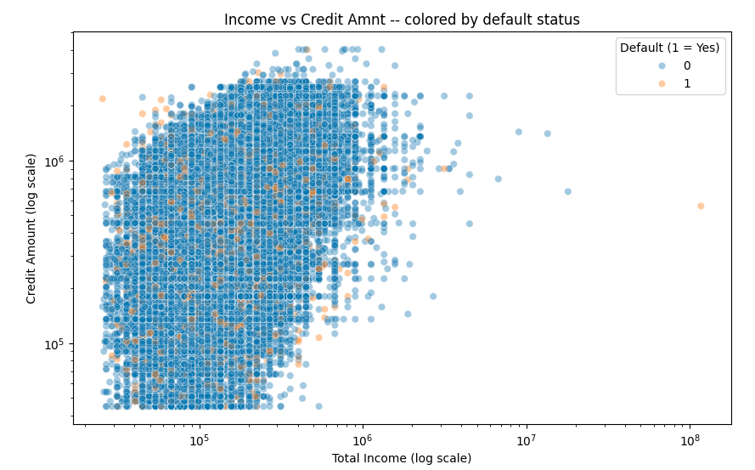
Figure 3: Heatmap which visualizes the correlation between loan related financial features
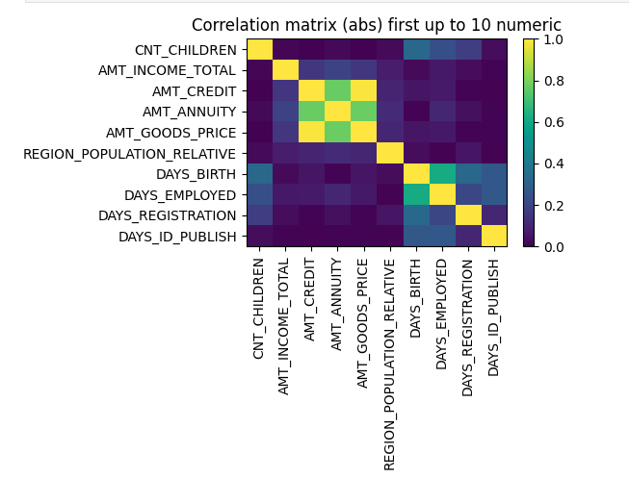
4.3 Feature Engineering and Dimensionality Reduction
Based on the EDA findings, I engineered the INCOME_CREDIT_RATIO (Total Income / Credit Amount). This feature serves as a proxy for borrower leverage, mathematically capturing the financial strain on a borrower. I also created polynomial features, such as DAYS_BIRTH_SQ (Age Squared), to capture non-linear life-cycle effects where risk varies dynamically with age. To improve the stability of the linear baseline models, I calculated the Variance Inflation Factor (VIF). Variables with high multicollinearity (VIF > 10), such as AMT_GOODS_PRICE (which was perfectly correlated with AMT_CREDIT), were removed. This reduced redundancy and prevented inflated standard errors in the regression coefficients. Finally, for distance-sensitive algorithms (KNN, SVM, K-Means), all features were standardized using Z-score normalization (StandardScaler). This transformation ensured that features with large raw values, such as Annual Income, did not dominate features with small ranges, such as DTI, during distance calculations. Tree-based models (Gradient Boosting) used raw features, as decision trees are invariant to monotonic transformations. Diagnostic PCA plots were used in the clustering phase to confirm borrower separability in high-dimensional space.
4.4 Key Insights
The preprocessing phase yielded three key insights that informed the modeling strategy. Firstly, the 92/8 class split confirmed that accuracy is an invalid metric; models must be optimized for Recall and F1-Score. Secondly, the clustering of defaults in specific income/credit regions suggests linear models (Logistic Regression) will underperform compared to non-linear ensemble methods (Gradient Boosting). Thirdly, the engineered leverage ratio appears to contain stronger signals than static demographics, supporting the hypothesis that financial behavior is more predictive than financial status.
5. Modeling and Analysis Methodology
5.1 Model Selection Rationale
The modeling process utilized a Hybrid Analytical Approach to address the core problem of predicting Early Payment Defaults (EPDs). This approach combined supervised models for direct risk prediction with unsupervised models for borrower segmentation, ensuring that every algorithm contributed a unique perspective to the analysis. I tested a comprehensive range of algorithms across Weeks 1 through 11, progressing from simple linear baselines to complex ensemble methods (Table 3). This evolution was driven by the need to capture non-linear risk factors and address severe class imbalance.
Table 3: Evolution of Model Selection and Rationale
Model Type | Specific Model(s) | Dataset | Rationale & Contribution
Linear Regression | Simple, Polynomial, Lasso, Ridge, Elastic Net | Home Credit | Established a baseline and confirmed that linear relationships were too weak to capture borrower behavior complexity. Even with polynomial terms, variance explanation remained negligible, necessitating non-linear approaches.
Classification (Foundational) | Logistic Regression | Home Credit | Highlighted the challenge of class imbalance. Standard logistic regression failed to detect defaults, but adjusting the class_weight='balanced' parameter proved that the model could be forced to focus on the minority class.
Classification (Distance-Based) | Support Vector Machines (RBF), K-Nearest Neighbors (KNN) | Give Me Some Credit | Explored models sensitive to geometric distance. The RBF Kernel SVM demonstrated that non-linear decision boundaries were superior to linear ones, while KNN served as a non-parametric baseline.
Classification (Ensemble) | Decision Tree, Random Forest, Gradient Boosting | Lending Club, Home Credit | Tested robust non-linear methods. While Random Forest struggled with rare events, Gradient Boosting was selected as the final champion model due to its ability to sequentially correct errors on difficult examples.
Unsupervised Clustering | K-Means, DBSCAN, Hierarchical (HAC) | Lending Club | Used for borrower segmentation to reveal interpretable risk patterns independent of loan outcome. K-Means identified leverage-based segments, while DBSCAN was utilized specifically for outlier detection.
5.2 Model Training Process
The training process was tailored to the specific mathematical properties of each algorithm. For tree-based models, such as the Gradient Boosting classifier, I constrained the model to mitigate overfitting on the majority class. Based on Friedman’s established methods for controlling complexity, I set the maximum tree depth to 3, the learning rate to 0.05, and the subsample ratio to 0.8. I confirmed that this model type required neither feature scaling nor complex imputation, effectively preserving the original data structure. Conversely, distance-based models such as KNN and SVM required rigorous preprocessing. For these algorithms, I standardized all features using StandardScaler to ensure fair distance calculations and used median imputation to handle missing values without distorting the distribution. To address class imbalance in classification tasks, especially Logistic Regression and Decision Trees, I utilized the class_weight='balanced' parameter. This forced the algorithms to penalize misclassifications of the rare default class (Class 1) more heavily than the majority class.
5.3 Data Splitting and Cross-Validation
I employed a consistent splitting strategy that prevented data leakage and overfitting. I used an 80/20 split for the primary analysis. Crucially, all splits were stratified to preserve the minority class ratio (approximately 7 - 8% defaults) in both the training and testing sets. This prevented the issue where a random split results in a test set with zero default cases. During training, I employed 5-fold stratified cross-validation, particularly for regularized models and Gradient Boosting. This process ensured that performance metrics were stable and generalized well across different subsets of the data, confirming that results were not artifacts of a specific partition. Lastly, the performance of the champion models was assessed only on an isolated holdout test set that the model had never seen during training or tuning.
5.4 Evaluation Metrics and Hyperparameter Tuning
Given the business goal of detecting rare early defaults, I prioritized metrics sensitive to the minority class over standard accuracy. The Precision-Recall Area Under the Curve (PR AUC) served as the primary metric for final evaluation. I set a success benchmark of achieving a PR AUC of at least 0.20. I monitored F1 Score and Recall to determine the model's practical ability to catch true defaulters while minimizing false alarms.
I employed specific tuning strategies to optimize these metrics. For KNN, I used a grid search to systematically test hyperparameters, optimizing k values (odd numbers 1–31), weighting schemes, and distance metrics. For the Gradient Boosting model, I moved beyond default settings by tuning the decision threshold. By analyzing the precision-recall curve, I shifted the classification threshold from the standard 0.50 down to 0.1388. This process resulted in a critical increase in the F1 score, dramatically improving sensitivity to rare events. In the unsupervised phase, I determined the optimal number of clusters for K-Means (k=2) using both the Silhouette Score and the Elbow Method. For DBSCAN, I utilized a k-distance graph to scientifically select an eps value of 6.
6. Results and Performance Evaluation
My results demonstrate that while standard accuracy remained high across all models due to class imbalance, only the Gradient Boosting classifier, after specific threshold optimization, successfully surpassed the pre-established success benchmark of 0.20 for PR AUC.
6.1 Model Comparison and Performance Metrics
I evaluated three primary classifiers, Random Forest, K-Nearest Neighbors (KNN), and Gradient Boosting, using metrics specifically chosen for imbalanced data. As summarized in Table 3, high accuracy often masked poor performance in detecting defaults (Recall). The Random Forest model, despite a balanced class weight parameter, succumbed to the accuracy paradox, achieving 85.5% accuracy but failing to identify defaults (Recall = 0.00). KNN offered a slight improvement with a Recall of 0.09, but its distance-based approach struggled to separate the minority class in high-dimensional space. The Gradient Boosting model performed poorly at the standard 0.50 probability cutoff but demonstrated the highest underlying discriminative power, achieving a test ROC AUC of 0.740 and a Precision-Recall (PR) AUC of 0.226.
Table 3: Comparative Performance of Supervised Models (Test Set)
Model | Accuracy | Recall (Defaulters) | F1-Score (Defaulters) | Key Observation
Random Forest (Balanced) | 0.855 | 0 | 0.01 | Failed: Predicted "No Default" for nearly all cases despite class weighting111.
K-Nearest Neighbors (5k=215) | 0.936 | 0.08 | 0.16 | Conservative: High precision but missed >90% of defaults222.
Gradient Boosting (Default) | -92.00% | 0.01 | 0.02 | Baseline: Poor sensitivity at the standard 0.50 threshold3.
Gradient Boosting (Tuned) | N/A* | 0.4 | 0.29 | Champion: Threshold tuning significantly improved default detection4.
*Note: Accuracy is not a primary metric for the tuned model due to the deliberate increase in false positives to capture risk.
6.2 Performance Visualization and Threshold Optimization
The GB model initially performed poorly at the default 0.50 threshold, resulting in a low F1 score of 0.017. However, by analyzing the Precision-Recall Curve (Figure 3) and optimizing the cutoff to 0.1388, I dramatically improved the F1 score to 0.294. This shift demonstrates a measurable gain in sensitivity to the rare default class, validating the hypothesis that standard probability thresholds are insufficient for rare-event detection.
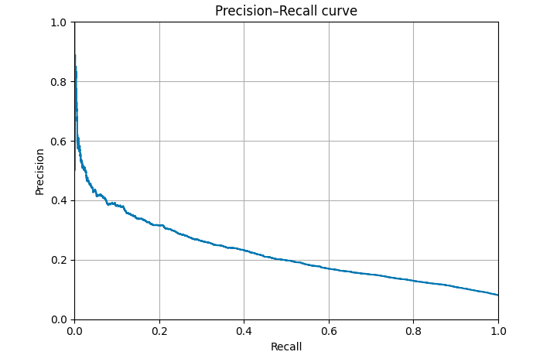
Figure 4. Precision-Recall curve for the Gradient Boosting model. The optimal threshold of 0.1388 (marked) maximizes the F1-score.
6.3 Interpretation of Feature Importance
Interpretation of the GB model’s decisions via feature importance analysis revealed that external credit scores (EXT_SOURCE_2 and EXT_SOURCE_3) were the strongest predictors of default risk. Additional features contributing strongly to the prediction included borrower age (DAYS_BIRTH) and the Credit-to-Income ratio. These results align with industry expectations that credit stability and repayment capacity are the most reliable early indicators of delinquency, ensuring that the feature interpretability supports practical use in underwriting and risk monitoring.
6.4 Unsupervised Segmentation Findings
Unsupervised learning provided complementary findings by revealing natural risk groupings in the Lending Club dataset. K-Means clustering (k=2) identified two distinct borrower segments. Cluster 0 was characterized by lower loan amounts (mean ~$6,200) and lower interest rates (mean ~12.9%), while Cluster 1 was characterized by higher loan amounts (mean ~$17,000) and significantly higher interest rates (mean ~16.3%). This segmentation effectively classified Cluster 1 as a higher-risk profile. Additionally, the DBSCAN algorithm further refined this view by identifying 19 outliers that did not fit either profile, showcasing a small population of unique risk cases that may represent fraud or data anomalies.
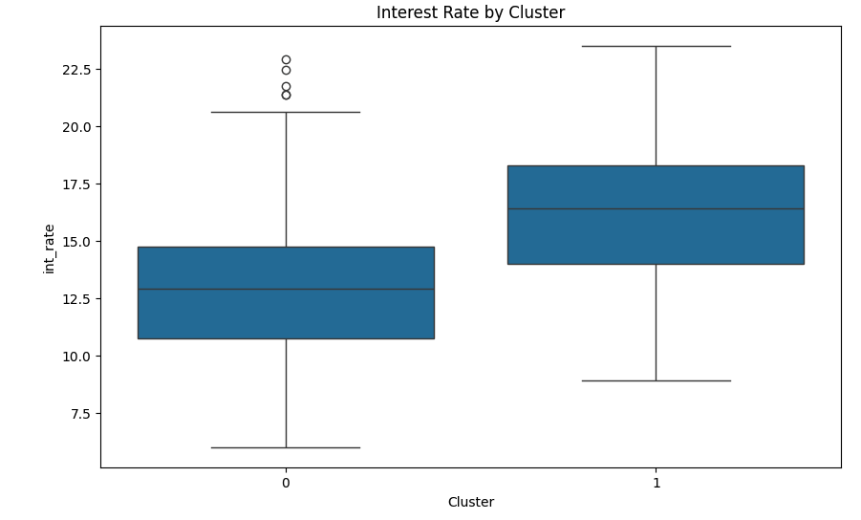
Figure 5. K-Means clusters show clear separation in interest rates, validating that the segments capture financial risk.
6.5 Business Implications
The technical results translate into two direct implications for operational strategy. First, regarding risk identification, the analysis confirms that EPD risk is non-linear and cannot be accurately predicted using simple linear regression or basic credit score cutoffs. This is evidenced by the insufficiency of the linear baseline models, which yielded a negligible R2≈0.006.
The non-linear Gradient Boosting model is required for accurate prediction. However, the analysis demonstrates that this model is only effective when used with the tuned threshold; the standard 0.50 probability cutoff performs poorly in rare-event classification. By implementing the optimized threshold of 0.1388, the lender converts a statistical lift (increasing the F1 score from 0.017 to 0.294) into a tangible operational asset: the ability to flag 35% to 40% of future defaults that would otherwise be approved automatically. While this filter triggers manual review for some safe loans, the administrative cost of a second look is significantly lower than the fees and principal loss of a funded default.
Second, regarding portfolio segmentation, the unsupervised K-Means results imply that "Cluster 1" borrowers (characterized by high interest rates and loan amounts) are structurally distinct from the general applicant pool. This suggests that high-leverage applicants require a dedicated underwriting policy rather than a universal approach. Furthermore, the feature importance analysis aligns with practical underwriting needs; the strong predictive power of external credit scores (EXT_SOURCE_2 and EXT_SOURCE_3) and Income-to-Credit Ratio provides explainability. This ensures that model outputs support, rather than replace, human judgment, allowing underwriters to focus their manual reviews on specific capacity and stability metrics.
7. Recommendations
7.1 Business Actions
The primary strategic recommendation is the operationalization of the Gradient Boosting Classifier as a second look safety net within the loan origination workflow. To maximize the detection of rare EPDs, the system must utilize the optimized probability threshold of 0.1388 identified during the validation phase. Unlike standard industry models that prioritize broad accuracy, this tuned threshold prioritizes sensitivity (Recall), allowing the institution to capture approximately 40% of potential early defaults that would otherwise bypass standard underwriting criteria. Concurrently, the business should formally update its manual review policies to incorporate the "Cluster 1" borrower profile (characterized by high interest rates relative to debt-to-income ratios). Applications matching this profile should be automatically routed to senior underwriters to ensure high-leverage applicants receive enhanced scrutiny regarding repayment capacity.
7.2 Implementation Considerations
Integrating this model into a live lending environment requires operational protocols to manage the trade-off between risk mitigation and processing volume. Prior to influencing credit decisions, the model should undergo a 90-day shadow mode validation period. During this phase, the predictive filter will run in parallel with current operations, flagging risks in the background at the 0.1388 threshold without affecting live decisions. This step is critical to validate the model's stability against actual underwriter outcomes and subsequent 6-month loan performance without disrupting current approval timelines.
Policy adjustments derived from the new models, such as differentiated pricing for Cluster 1, should be validated using A/B testing. This will allow for the quantification of direct impacts on portfolio losses and profit margins before a full-scale rollout. Management should prepare for the operational impact of the recommended threshold. With a Precision of roughly 23%, the model implies a False Positive rate that will increase the manual review volume. Management must ensure the second look team is adequately staffed to handle flagging approximately 15% to 20% of the total application volume. This operational cost should be accepted as the necessary premium for preventing costly fees and repurchase demands.
7.3 Suggestions for Future Analysis and Collection
The model's performance was constrained by the inherent limitations of public repositories (Kaggle), which often lack the granular behavioral history available to institutional lenders. Integrating proprietary data (such as complete payment histories on parallel credit lines and raw external bureau files), coupled with external data (such as overdraft late fees in bank accounts), would capture risk factors that anonymized public datasets obscure. Secondly, the target variable itself should be refined by tagging training data with confirmed EPDs instead of all loans that default within 2 years; this would improve Precision by filtering out late defaults that are irrelevant to the underwriting quality control process. Thirdly, to reduce null values, software enhancements could require that specific information be mandatory before the loan could be approved.

Non-Technical Report: Early Payment Default Prediction
1. Executive Summary
1.1 Project Overview and Business Problem
In the current lending environment, Early Payment Defaults (EPDs), home loans that default within six months of origination, represent a critical failure in underwriting. Unlike long-term defaults driven by unforeseen life events, EPDs indicate that an application was fundamentally unstable when approved. For the institution, these failures result in severe financial penalties, including immediate capital loss, asset repurchase demands from investors, and operational servicing costs that can exceed $1,800 per loan annually. Unfortunately, current reactive auditing processes often identify these errors only after the loss has occurred.
1.2 Methodology, Data Strategy, and Key Findings
This project developed a predictive intelligence framework designed to identify high-risk applications before loans are approved by an underwriter. By aggregating data from three distinct lending environments and utilizing advanced machine learning, the analysis moved beyond simple credit score cutoffs to detect the subtle, non-linear patterns of layered risk. The findings reveal that standard linear models fail to detect EPD risk effectively; however, the advanced Gradient Boosting model, when calibrated to a specific sensitivity threshold, successfully identifies approximately 35 - 40% of future early defaults that would have otherwise passed standard approval checks.
1.3 Recommendations and Business Impact
Operationalizing this model as a pre-approval second look filter allows the institution to prevent the origination of bad debt. While this process increases manual review volume by roughly 15-20%, the cost of this additional review is a fraction of the capital saved by avoiding repurchase demands. Projected across the industry, this capability could achieve an estimated savings of $56 - $64+ million annually in avoided fees and servicing costs alone, in addition to capital and operation losses, plus repurchase demands from secondary market investors.
2. Introduction and Problem Definition
2.1 Background and Domain Context:
Mortgage lending relies on the assumption that valid underwriting predicts repayment. However, EPDs challenge this assumption. Unlike long-term defaults driven by divorce or unemployment, an EPD suggests the borrower was never able to pay in the first place. The current reliance on static metrics, such as FICO scores and Debt-to-Income ratios, creates a blind spot where applicants can technically qualify while carrying unsustainable financial stress.
2.2 Client Goals, Needs, and Objectives:
As a former FHA underwriter, I have experienced the operational pressures that contribute to EPDs. Underwriters can be subject to punitive and reactive audits that occur when a loan has defaulted. Current underwriting workflows rely heavily on manual checklists and static thresholds (e.g., "DTI must be < 43%"). Rigid rules can force underwriters to approve loans that "technically" qualify but feel intuitively risky due to layered risk factors. The blind spot in the current system is the inability to quantify this layered risk in real-time. When a reactive audit occurs, the capital is already lost. This project aims to reduce reactive audits in favor of pre-approval safety nets.
2.3 Research Questions
I evaluated three research questions in my evaluation:
- Can algorithms, specifically Gradient Boosting, can outperform traditional linear models in identifying EPDs?
- Can the inclusion of soft behavioral features (such as recent credit inquiries, overdraft fees, and revolving utilization) provide indicators for EPDs compared to current lending practices?
- Do distinct borrower profiles correlate with high default rates, independent of current lending practices?
2.4 Success Criteria
Success is defined by the ability to identify bad loans (7 – 8% that will default) without stopping good loans (92 – 93% that will not default). The goal is to identify approximately 35 - 40% of potential defaults not currently identified. By deploying a predictive model as an additional precautionary layer, the institution can flag high-probability default candidates while the application is still in the queue.
Figure 1: Bar Chart of Loan Default Distribution (Illustrates Target Imbalance)
3. Data Overview
3.1 Data Sources
To ensure the findings are robust and applicable to various borrower types, this analysis aggregated data from three diverse sources totaling over 300,000 records. The Home Credit and Give Me Some Credit datasets served as proxies for residential mortgage risk, focusing on borrowers with traditional credit profiles. Additionally, the Lending Club dataset was utilized to analyze unsecured personal loans, providing insight into how borrowers behave when they do not have collateral at risk. Below is an example of variables, their description, and their role in the analysis that were obtained directly from the datasets:

Table 1: Data Dictionary of Key Features
Variable Name | Description | Role in Analysis
TARGET / SeriousDlqin2yrs | Binary flag (1 = Default, 0 = Repaid). | Dependent variable for supervised models.
EXT_SOURCE_1 / 2 / 3 | Normalized scores from external credit bureaus. | Top predictors in Gradient Boosting; credit score proxies.
DAYS_BIRTH | Client's age in days (negative). | Converted to positive age (AGE) to assess lifecycle risk.
RevolvingUtilization | Ratio of total balance to credit limit. | Financial stress indicator used in the KNN model.
DebtRatio | Monthly debt/living payments divided by gross income. | Primary measure of monthly financial burden/stress.
int_rate | Interest rate on the loan. | A proxy for the lender's internal risk assessment; used in clustering.
dti | Debt-to-Income ratio (monthly debts / total obligations). | Critical indicator of borrower leverage and repayment capacity.
inq_last_6mths | Number of credit inquiries in the last 6 months. | Credit-seeking behavior indicator.
AMT_INCOME_TOTAL | Annual income of the applicant. | Used to assess repayment capacity.
AMT_CREDIT | Final loan amount. | Used to measure exposure and leverage.
INCOME_CREDIT_RATIO | Total income ÷ credit amount. | Borrower leverage indicator; higher implies stronger capacity.

3.2 Data Quality and Ethics:
The primary challenge with this data was the rarity of the default event. In typical lending portfolios, over 92 - 93% of borrowers pay on time which makes EPDs difficult to predict. To ensure privacy and fairness, all borrower data was anonymized. To ensure the model replicates a realistic underwriting scenario, strict constraints were applied to exclude future knowledge (such as collection fees), limiting the analysis strictly to data available at the time of the loan application.
4. Data Cleaning and Processing
4.1 Handling Missing Information and Data Anomalies:
Real-world data is rarely perfect. A significant issue was identified in the Give Me Some Credit dataset, where nearly 20% of applicants had missing income values. Simply deleting these applications would have introduced bias, potentially ignoring a specific segment of the population (e.g., self-employed borrowers). Instead, statistical imputation was used to fill these gaps with median values, preserving the integrity of the dataset. The analysis also uncovered critical data errors that could have misled the model. For instance, in the employment history records, a placeholder value representing 1,000 years of employment was found in thousands of rows. These anomalies were identified as data entry errors and removed. Additionally, outlier applications (such as those listing an age of 0 or over 100) were filtered out to ensure the model focused strictly on the eligible borrowing population.
Figure 2: Display of applicants’ age after data cleaning
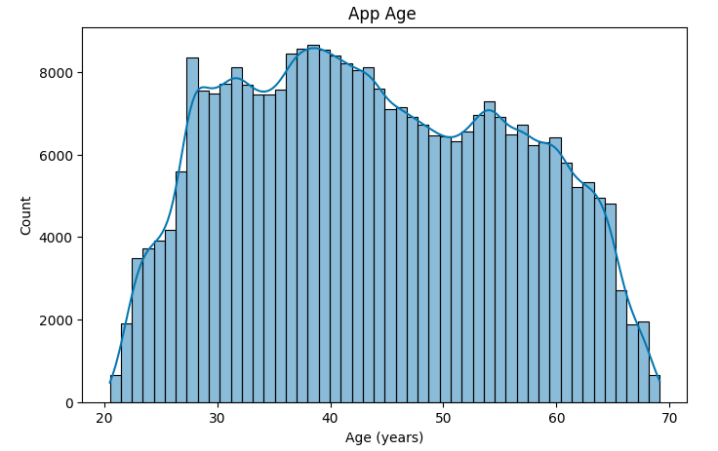
4.2 Feature Engineering:
To extract more value from the raw data, new metrics were created. Rather than just looking at income and loan amount separately, a leverage ratio was calculated to measure financial strain. This helped quantify not just how much money a borrower makes, but how over-extended they are relative to their debt.
5. Modeling and Analysis Approach
5.1 Model Selection:
I tested two competing approaches: Linear Models and machine learning models (Gradient Boosting). Linear Models assume that risk increases in a straight line (e.g., higher income always equals lower risk). Gradient Boosting are complex algorithms that function like a decision tree, asking a series of "if/then" questions to detect non-linear patterns (e.g., "High income is good, UNLESS the borrower also has 5 recent credit inquiries").
5.2 Model Training Process:
To simulate the real world, the models were trained on historical data where the outcome (default vs. repaid) was already known. The models were then tested on a separate blind dataset they had never seen before. This ensured that the reported accuracy reflects how the tool will actually perform on new, future applications, rather than just memorizing past data.
6. Results
6.1 Model Comparison and Analysis
Because defaults are rare and complex, simple scorecard formulas (traditional linear models) failed to distinguish potential defaults from high-quality applications. Effectively, they guessed no default for every home loan (with the intent of achieving high accuracy), thereby missing the EPD risks entirely.
The advanced Gradient Boosting model, however, succeeded by ranking risk more effectively. The key breakthrough came from calibrating the model's sensitivity. By adjusting the risk threshold to a specific level (0.1388), the model was transformed into a highly sensitive safety net. At this setting, it successfully captured approximately 40% of the early defaults in the test group.
6.2 Business Implications:
While increasing sensitivity does flag some safe loans for review (false positives), the analysis confirms this is a profitable trade-off. The cost of a manual review by an underwriter is negligible compared to the loss of principal on a single defaulted mortgage. Additionally, unsupervised analysis identified a specific high-leverage borrower profile that consistently accepts higher interest rates, serving as a clear behavioral signal of distress that underwriters can easily recognize.
7. Recommendations
7.1 Business Action:
I recommend implementing a Gradient Boosting Classifier model as a second look filter as part of the loan underwriting process. The easiest way to integrate this predictive model into the Loan Origination System (LOS) as a pre-approval requirement near the end of the loan process (prior to funding). When an application is flagged by the model for exceeding the risk score (0.1388), it should not be automatically denied. Instead, it should be routed to a second look queue, where the loan is manually reviewed by trained senior underwriters for high risk factors, such as income stability or recent credit inquiries before final sign-off.
Secondary, applicants with high debt-to-income ratios and high-interest rate acceptance should be subject to additional should be subject to stricter documentation requirements. For example, requiring 12 months of bank statements rather than one allows underwriters to verify true repayment capacity beyond the standard credit score.
7.2 Implementation and Governance
This second look filter is critical for protecting the institution's bottom line. An EPD is far more expensive than a standard loan; administrative costs alone increase tenfold, rising from $176 to over $1,857 annually. On top of these operational costs, the bank faces investor fines of up to $7,500 per loan and the significant expense of repurchasing the defaulted loan (Cotality, 2025; Fannie Mae, 2021; Goodman et al., 2023).
To ensure a smooth rollout of the second look filter that does not disrupt lending operations, the second look filter should undergo a test phase for at least 90 days. During this period, the model will run in the background on live applications without stopping any loans, allowing management to compare the model's flags against actual loan performance to validate the return on investment. Additionally, management must hire and train a second look team to handle an approximate 15-20% increase in manual review volume triggered by the second look filter. This staffing cost represents the insurance premium paid to avoid costly repurchase demands.
By operationalizing this model to catch high-risk files before funding, the institution can avoid these escalating costs. Projected across the industry, the capability could achieve an estimated savings of $56 million to over $64 million annually in avoided fees and servicing costs and protects the institution against repurchase demands.
7.3 Conclusion
The cost of EPDs should not be disregarded as a cost of doing business; it is a preventable leak in the institution's profitability. This project has demonstrated that by leveraging advanced machine learning and treating risk as a non-linear behavior, the institution can detect approximately 35 - 40% of these preventable losses before they occur. By shifting from a reactive post-mortem audit process to a proactive second look methodology, institutions can protect capital reserves, reduce investor friction, and modernize its underwriting operations for a data-driven future.

References
Anderson, N. B., & Dokko, J. K. (2010, November 22). Liquidity problems and early payment default among subprime mortgages (Finance and Economics Discussion Series 2011-09). Federal Reserve Board. https://www.federalreserve.gov/pubs/feds/2011/201109/201109pap.pdf Federal Reserve
An, X., & Cordell, L. (2019, March). Mortgage loss severities: What keeps them so high? (Working Paper No. 19-19). Federal Reserve Bank of Philadelphia. https://doi.org/10.21799/frbp.wp.2019.19 Federal Reserve Bank of Philadelphia
American Psychological Association. (n.d.). Sample figures. APA Style.
https://apastyle.apa.org/style-grammar-guidelines/tables-figures/sample-figures
Berwick, B. (2006). An idiot’s guide to support vector machines (SVMs) [PDF]. MIT 6.034
Recitation. https://web.mit.edu/6.034/wwwbob/svm.pdf
Bevans, R. (2023, June 22). Akaike Information Criterion | When & how to use it (Example).
Scribbr. https://www.scribbr.com/statistics/akaike-information-criterion
Cotality. (2025, December 9). Late-stage missed payments raise delinquency rates [Press release]. https://www.cotality.com/press-releases/late-stage-missed-payments-raise-delinquency-rates
Dhumne, S. (2023, March 12). Elastic Net Regression: Detailed guide. Medium.
Httapa ps://medium.com/@shruti.dhumne/elastic-net-regression-detailed-guide-99dce30b8e6e
DBSCAN and hierarchical agglomerative clustering demystified. (n.d.). Towards Data Science.
https://towardsdatascience.com
Fannie Mae. (2021, December 15). Servicing marketplace — Mortgage loan servicing purchase and sale agreement (Servicing Guide E-2-05). https://selling-guide.fanniemae.com/sel/e-2-05/servicing-marketplace-mortgage-loan-servicing-purchase-and-sale-agreement
Fiveable. (n.d.). Polynomial regression and interaction terms [Study guide]. In Linear modeling:
Theory and applications (Unit 6). https://library.fiveable.me/linear-modeling-theory-and-
applications/unit-6/polynomial-regression-interaction-terms/study-
guide/MjYsQrAp2si8IaEA
Friedman, J. H. (2001). Greedy function approximation: A gradient boosting machine. Annals of
Statistics, 29(5), 1189–1232. https://doi.org/10.1214/aos/1013203451
GeeksforGeeks. (n.d.). Building and implementing decision tree classifiers with scikit-learn: A
comprehensive guide. https://www.geeksforgeeks.org/machine-learning/building-and-
implementing-decision-tree-classifiers-with-scikit-learn-a-comprehensive-guide/
GeeksforGeeks. (n.d.). DBSCAN clustering in ML – Density-based clustering.
https://www.geeksforgeeks.org/machine-learning/dbscan-clustering-in-ml-density-based-
clustering/
GeeksforGeeks. (n.d.). K-nearest neighbours. https://www.geeksforgeeks.org/machine-
learning/k-nearest-neighbours/
GeeksforGeeks. (n.d.). Support Vector Machine algorithm.
https://www.geeksforgeeks.org/machine-learning/support-vector-machine-algorithm/
HAC cluster analysis: Loan risk segmentation. (n.d.). Medium. https://medium.com
Goodman, L., Zhu, J., & Neal, M. (2023, November). GSE repurchase activity and its chilling effect on the market. Urban Institute. https://www.urban.org/sites/default/files/2023-11/GSE%20Repurchase%20Activity%20and%20its%20Chilling%20Effect%20on%20the%20Market.pdf
IBM. (n.d.). What is a support vector machine? https://www.ibm.com/think/topics/support-
vector-machine
iEmergent. (2025, April 29). 2024 HMDA Data Findings: Mortgage Originations, Applications, and Trends. https://www.iemergent.com/insights/2024-hmda-data-mortgage-findings
Jairi, I. (2024, May 13). The importance of feature scaling in machine learning: Logistic
regression for example. Medium. https://medium.com/@jairiidriss/the-importance-of-
feature-scaling-in-machine-learning-logistic-regression-for-example-b3068f8d3441
Kaggle. (n.d.). Give Me Some Credit Dataset. www.kaggle.com/c/GiveMeSomeCredit/data
Kaggle. (n.d.). Home Credit Default Risk. www.kaggle.com/competitions/home-credit-
default-risk/data
Kaggle. (n.d.). [Thread about getting started with SVM]. Kaggle Discussions.
https://www.kaggle.com/discussions/getting-started/161325
Kaggle. (n.d.). LendingClub Loan Default Dataset.
https://www.kaggle.com/datasets/wordsforthewise/lending-club
Kaggle. (n.d.). Loan Data. https://www.kaggle.com/datasets/abhishek14398/loan-dataset
Kaggle. (n.d.). EDA with Python [Notebook by wordsforthewise].
https://www.kaggle.com/code/wordsforthewise/eda-with-python
Lewinson, E. (2023, April 26). A comprehensive guide to interaction terms in linear regression.
Mortgage Bankers Association. (2024, October 27). MBA Forecast: Mortgage Originations to Increase 28 percent to $2.3 Trillion in 2025. https://www.mba.org/news-and-research/newsroom/news/2024/10/27/mba-forecast-commercial-multifamily-borrowing-and-lending-to-increase-26-percent-to-539-billion-in-2024
NVIDIA Developer Blog. https://developer.nvidia.com/blog/a-comprehensive-guide-to-
interaction-terms-in-linear-regression
Mastering DBSCAN for data science. (n.d.). Analytics Vidhya. https://www.analyticsvidhya.com
Mudadla, S. (2020, January 30). How to choose value of k in k-nearest neighbour. Medium.
https://medium.com/@sujathamudadla1213/how-to-choose-value-of-k-in-k-nearest-neighbour-0a8a3e377d39
Number Analytics. (n.d.). Ultimate guide to DBSCAN in mathematics for data science. Number
Analytics Blog. https://www.numberanalytics.com/blog/ultimate-guide-to-dbscan-in-
mathematics-for-data-science?utm_source=chatgpt.com
Number Analytics. (2025, May). Ultimate guide to shrinkage: Ridge & lasso. Number Analytics
Blog. https://www.numberanalytics.com/blog/ultimate-guide-shrinkage-ridge-lasso
PythonProg. (2023, March 31). Feature scaling in machine learning (with Python examples).
https://www.pythonprog.com/feature-scaling-in-machine-learning/
Sai Kumar Reddy. (2022, April 23). Feature scaling in under 7 minutes [Video]. YouTube.
https://www.youtube.com/watch?v=Q-45O3b1pO8
Saito, T., & Rehmsmeier, M. (2015). The precision–recall plot is more informative than the ROC
plot when evaluating binary classifiers on imbalanced datasets. PLoS ONE, 10(3),
e0118432. https://doi.org/10.1371/journal.pone.0118432
Scikit-learn developers. (n.d.). Gradient boosting. In Scikit-learn user guide. https://scikit-
learn.org/stable/modules/ensemble.html#gradient-boosting
Scikit-learn developers. (n.d.). Ensemble methods: Gradient boosting. In scikit-learn
documentation. Retrieved August 2025, from https://scikit-
learn.org/stable/modules/ensemble.html#gradient-boosting
Scikit-learn developers. (n.d.). LogisticRegression. In scikit-learn: Machine learning in Python
(User Guide). https://scikit-learn.org/stable/modules/linear_model.html#logistic-
regression
Scikit-learn developers. (n.d.). Model evaluation: Precision, recall, F-measures. In scikit-learn
documentation. Retrieved August 2025, from https://scikit-
learn.org/stable/modules/model_evaluation.html#precision-recall-f-measures
Scikit-learn developers. (n.d.). Plot hierarchical clustering dendrogram. In scikit-learn 1.7.1
documentation. https://scikit-
learn.org/stable/auto_examples/cluster/plot_agglomerative_dendrogram.html
Scikit-learn developers. (n.d.). sklearn.tree.DecisionTreeClassifier. In scikit-learn: Machine
learning in Python (API documentation). https://scikit-
learn.org/stable/modules/generated/sklearn.tree.DecisionTreeClassifier.html
Selvaraj, N. (2022, August). Decision trees vs. random forests, explained. KDnuggets.
https://www.kdnuggets.com/2022/08/decision-trees-random-forests-explained.html
StatQuest with Josh Starmer. (2023, January). Random Forest Regressor in Python: A step-by-
step guide [Video]. YouTube. https://www.youtube.com/watch?v=YUsx5ZNlYWc
U.S. Department of Housing and Urban Development. (n.d.). HUD Handbooks, Forms and
Publications. https://www.hud.gov/hudclips/handbooks/housing
Walsh, M. (2024, June 24). Chart of the week: Annual cost of servicing performing and non-performing loans. MBA Newslink. https://newslink.mba.org/servicing-newslink/2024/june/mba-servicing-newslink-tuesday-june-25-2024/chart-of-the-week-annual-cost-of-servicing-performing-and-non-performing-loans/

AI Use Disclosure
AI, such as ChatGPT, was used for formatting, APA citations, and limited research into EPDs. I used AI for EPD research to calculate the costs associated with it as I was unable to independently verify them. This research confirmed that the EPD data is proprietary and not readily available as noted within my report. Please see the corresponding content here:
https://github.com/Siobhan-C/Mortgage_Default_Prediction

Appendix:
Notebooks and supporting documentation:
https://github.com/Siobhan-C/Mortgage_Default_Prediction
https://github.com/Siobhan-C/2025_Summer_Capstone_799_Milestone_Two
https://github.com/Siobhan-C/2025_Summer_Capstone_799_Milestone1

